**Sev: 3 (medium)**

**Type: Bug**

**Title: From "Events" page cannot goes to an "Event" page**

**Summary:**

When the host tries go to any "Event" page from "Events" page, the "Event" page displays with a message “Page not found”.

**Prerequisites:**

* Have valid credentials for the following URL: <http://building-tst.jalasoft.local:3202/>.
* Have a browser already installed (E.g. Chrome)
* Have a “Event” already created (E.g. ConcertA)

**Steps:**

* Go to : <http://172.21.18.52:3202/>

1. Enter the credentials.
2. Click on the “Bell” icon on the left-nav menu.
3. Click on “Event” (Requirement)

Notice that a page is displayed with the following message “Page not found”

**Actual results:**

Event details is not displayed

**Expected results:**

From “Events” page should be go to "Event" page where displays all details of this event.

**Environment:**

* Windows 10
* <http://172.21.18.52:3202/>

**Workaround:**

1. Go to : <http://172.21.18.52:3202/>
2. Enter the credentials.
3. Click on the “Bell” icon on the left-nav menu.
4. Click on “Añadir Invitado” button in the “Event” section.

*-*-*-*-*-*-*-*-*-*-*-

**Sev: 3 (medium)**

**Type: Enhancement**

**Title: Add a Search field on the “Events” page**

**Summary:**

Many events can be created in a day, and for a Host is difficult to find an event on the "Events" page.

add a search field on this page that search by:

- Event name

- Event date

- Event location

**Prerequisites:**

* Have valid credentials for the following URL: <http://172.21.18.52:3202/>
* Have a browser already installed (E.g. Chrome)
* Have a “Event” already created (E.g. ConcertA)

**Steps:**

1. Go to : <http://172.21.18.52:3202/>
2. Enter the credentials.
3. Click on the “Bell” icon on the left-nav menu.

**Actual results:**

All events are displayed and it is not possible to search an event.

**Expected results:**

The Host should be can searching an event on the “Events” page

**Sev: 4 (Low)**

**Type: Bug**

**Title: “Event changed status” message is displayed on the “Events” page**

**Summary:**

This issue is random.  
After the host edit the event, return to the “Events” page, the “Event changed status” is displayed next to the Event date and not disappear.

Please reviewed the attach image.

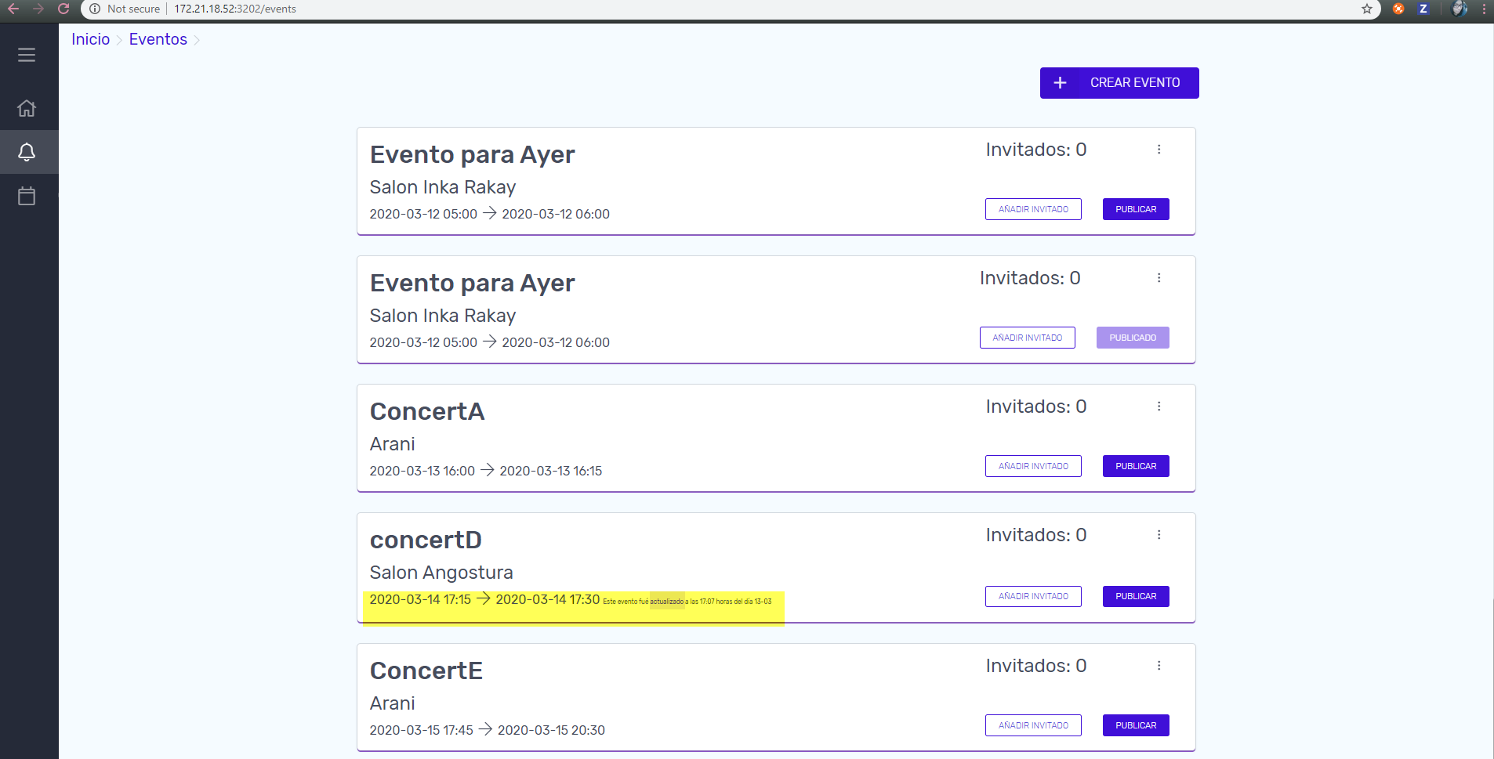

**Prerequisites:**

* Have valid credentials for the following URL: <http://172.21.18.52:3202/>
* Have a browser already installed (E.g. Chrome)
* Have a “Event” already created (E.g. ConcertD)

**Steps:**

1. Go to: <http://172.21.18.52:3202/>
2. Enter the credentials.
3. Click on the “Bell” icon on the left-nav menu.
4. Click on “Añadir Invitado” on the Event (Requirement) section
5. Click on “Editar” button
6. Change any value (E.g. Location).
7. Click on “Guardar” button
8. Go to the “Events” page
9. Review the Event

Notice that the Event is edited.

**Actual results:**

“Este evento fué actualizado a las 17:07 horas del día 13-03” message is displayed next to “Event” date.

**Expected results:**

**“Event changed status” message should not be displayed after edit next to Event date**

**Environment:**

* Windows 10
* <http://172.21.18.52:3202/>